BP26311 -Spring loaded pin connector

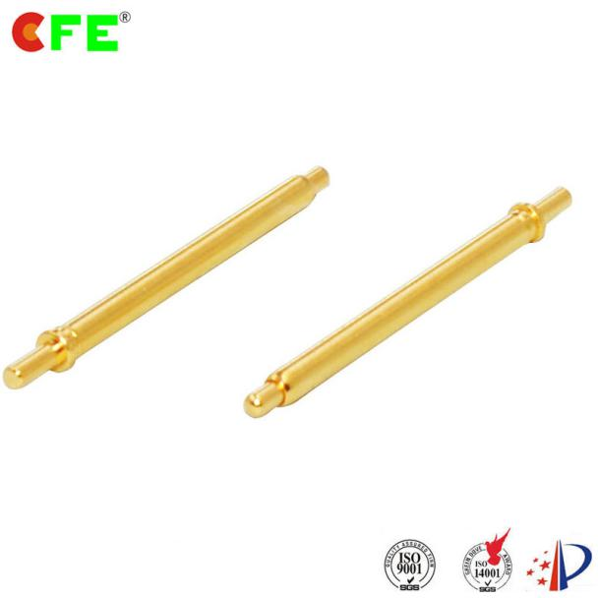
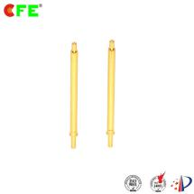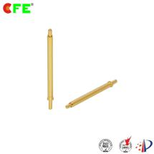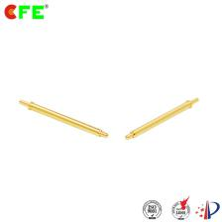

横幅 1：Leading pogo pin manufacturer

waterproof、Hight current、long life span
产品优势：
- CFE pogo pin strong points:
1. World's first manufacturer developed large current pogo pin with 20A, 15A series has been mass produced
2. World's second manufacturer developed 1.27 pitch pogo pin connector
3. Asia's first manufacturer achieved compression mechanical 1 million life times
4. Asia's first professional medical, industrial, special industries such as automobile industry suppliers
5. China's first pogo pin product with magnet combined connector manufacturer and own most solutions
PDF图纸下载

Products details:
Materials:
. Plunger: | brass Au（C3604/C3602）over Ni | 不易腐蚀、氧化、提高导电率。减少阻抗
. Barrel: | brass Au (C3604/C3602) over Ni
. Spring: | SUS (304) | 稳定，耐腐蚀性好
- Mechanical:
. Spring force: | 90 to ±20g at 1.0mm working stroke .
. Full stroke: | 1.40mm
. Life test: | 100,000 cycles
- Electrical:
.Rated current and voltage: | 12V DC, 1A max
. Contact-resistance: | 50milli ohms max .The contact is more stable and the conductivity will be better | 接触更稳定，那样产品的导电效率就更好

Type of Pogo pin

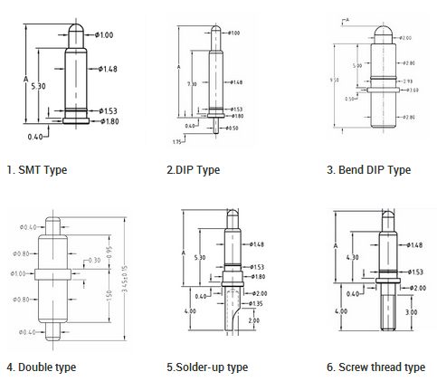

CFE可以依据图纸定制大电流pogopin,精密pogopin连接器,或根据客户的具体需求提供解决方案，定制符合客户产品结构的弹簧针。

Pogo pin Application

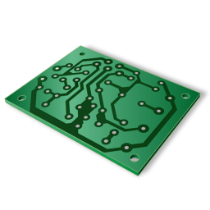 | 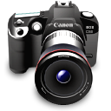
PCB board | Digital camera | Medical products | Printer cartridges
Golf handle | Electric vehicles | Telephony application | Cardiac defibrillator
 | 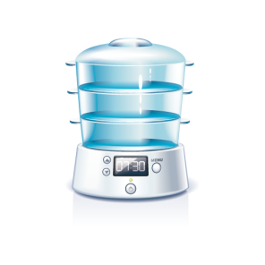
Car charging | Air purifier | LED flat luminaries | PC
Power bank | Signal transmission products | Charging products | Small household electrical application

Cfe Corporation Co.,Ltd.
行动力号召话术
Tel: (86) 769-8166-8560

Fax: (86) 769-8288-2401

Mob: (86) 13434524996

E-mail: cfe@cfconn.com

Web: http://www.cfconn.com

Factory Add: 3F.NO.4,Zhen Rong Rd.Wusha.Changan Town,DongGuan City,Guangdong Province,China

HK Office: Unit 905,Workingberg Commercial Building,41-47Marble Road, HongKong

定制产品内页模板+表格
Customization

Part No | A | B | C | D | E | F | PDF(drawing down)
BP17701
表格（多列参数、列表可以排序、可以直接查询、下载按钮）
立即咨询（找不到合适的料号，需要定制！）

